**Domain Competency**

Here is a simple manual to help you fill the Domain competency. This module seeks to capture the domain related knowledge and experience of Nouseans. Below is the” how to do it yourself” details.

**Step 1**

Please select the domain that you have worked in. The screen will be as given below.

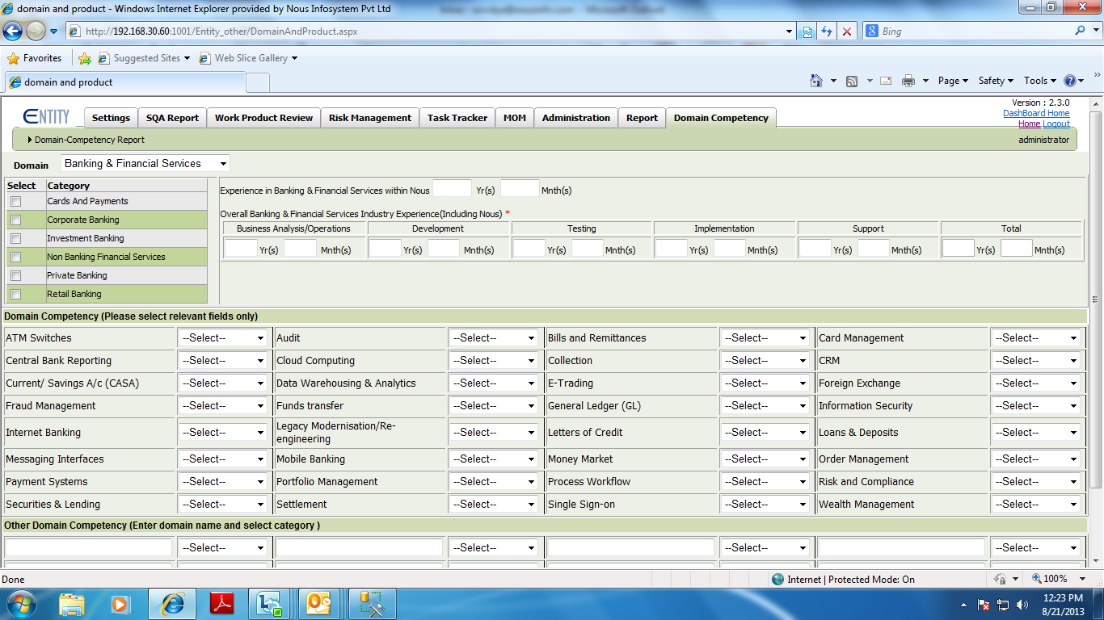

Please select the categories under domain in which you have worked.

Please fill the years of experience.

The domain competency areas are listed. Select the level based on your competency in that area.

If the listed areas do not cover what you have experience in, we have provided a section ‘Other Domain Competency’ . Please add the name and select the level of competency.

Save and go to the next page

**Step 2**

Page 2 has the product information. Choose the products you have worked on. Similar to page 1 if you have worked in any products that is not listed please update in “other” column

**Step 3**

In the same page further down you have the space to fill the Certification if any that you have done. You can add as many ever certification that you have done.

There ends the process ,simple and Fast☺.

In case you have no previous experience in any of the mentioned domains please hold on. Once those are updated we will keep you informed.

We hope this would have helped you to fill the details. If you still have any doubts or queries please send in a mail to dcd@nousinfo.com.